**End of Key Stage 1 results 2020**



**Year one phonic screening check 2020**



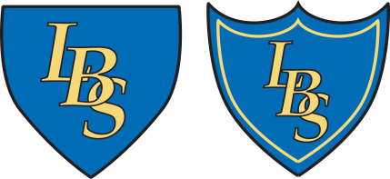**End of Key Stage 2 results 2020**



****Due to COVID-19, there are no results to display for the school year 2020-21 due to assessments not taking place****